SQL Lab Questions
Table1 students: -
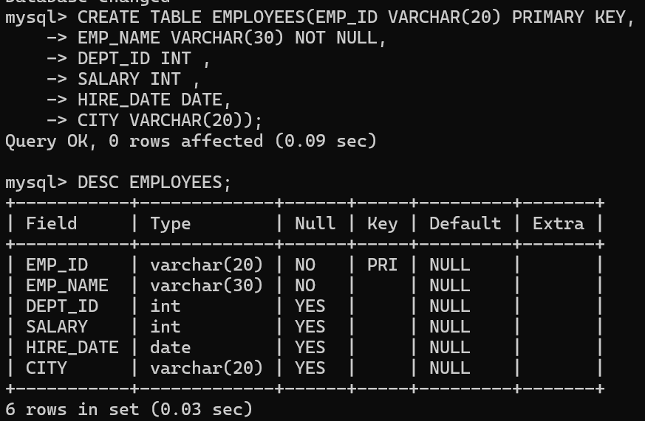
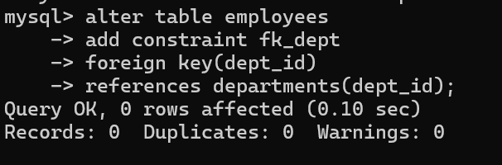
Table2 departments: -

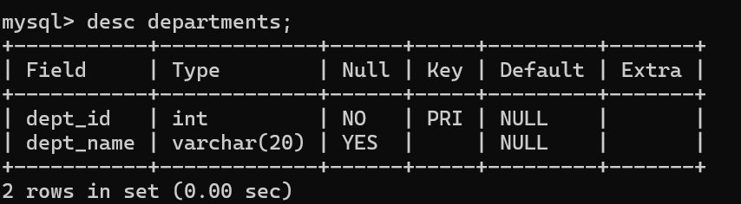
Table3 projects:-
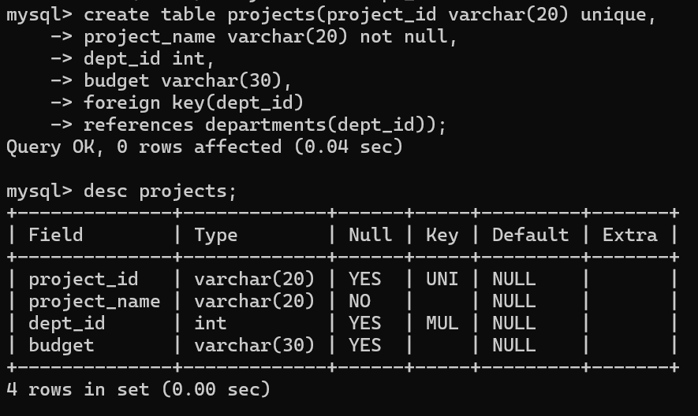

Table4 attendence: -
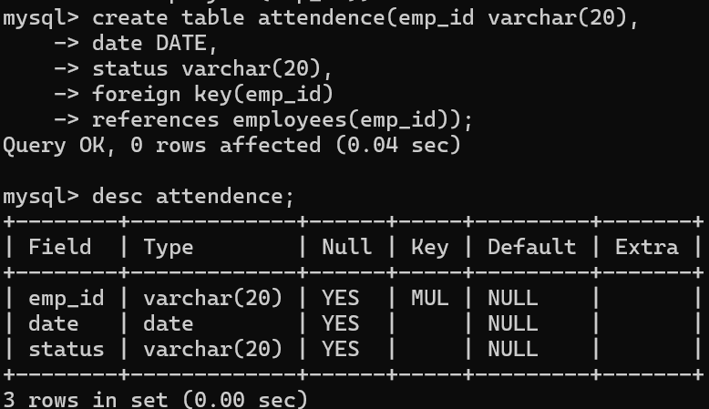
Ques1 Retrieve all employees.
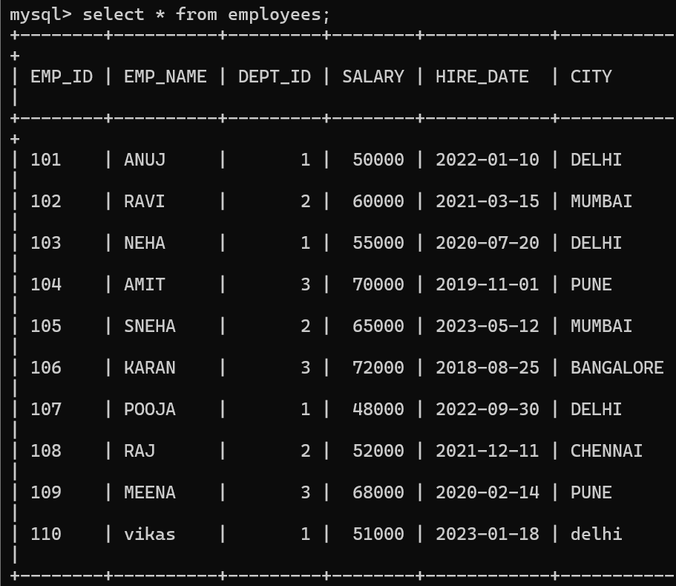
Ques2 Display only emp_name and salary.
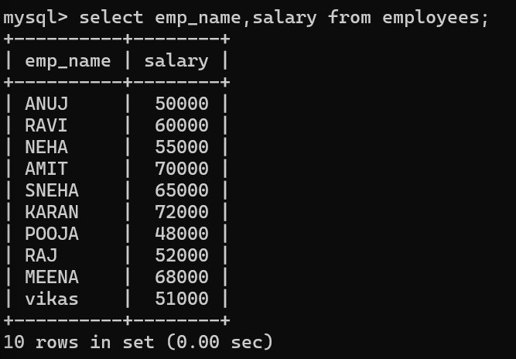

Ques3 Find employees working in department 1.
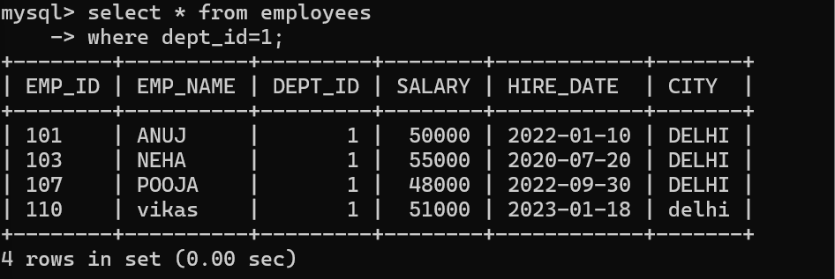
Ques 4 List employees from Delhi.
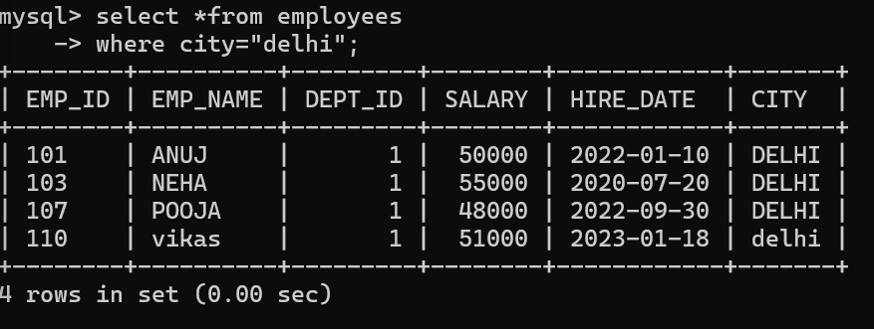
Ques5 Show employees with salary greater than 60000.
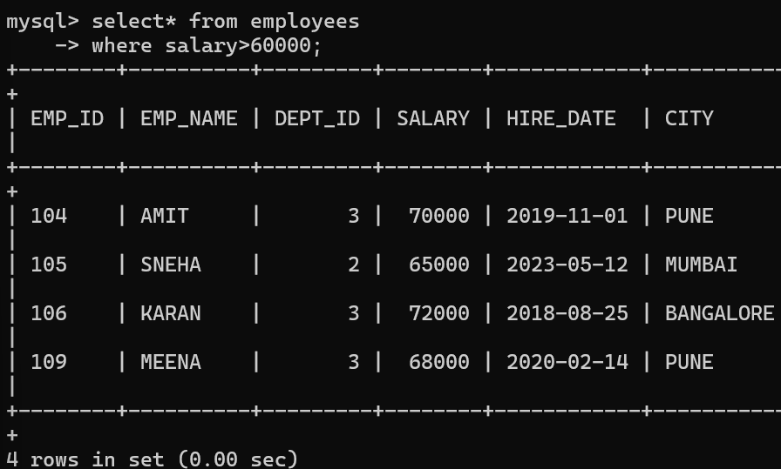
Ques6 Find employees hired after 2021.
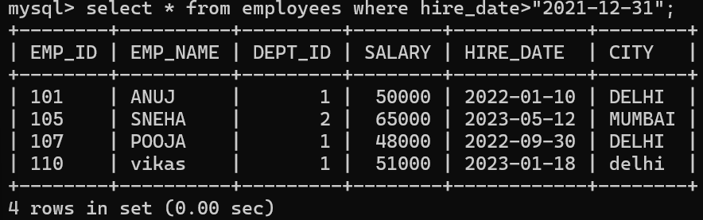

Ques7Display unique cities.
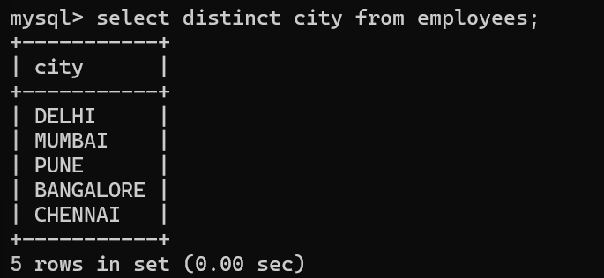
Ques8Sort employees by salary (descending)
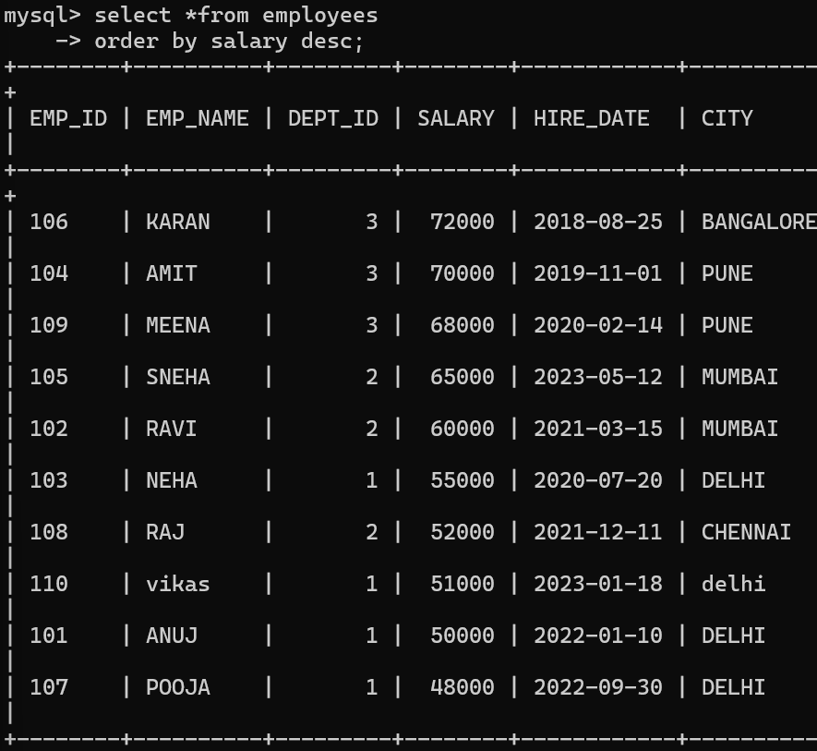
Ques9Count total employees. 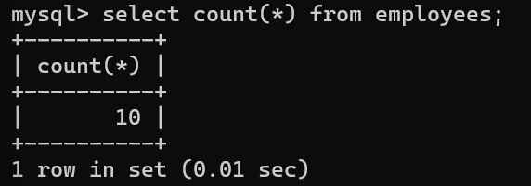
Ques10Find average salary.
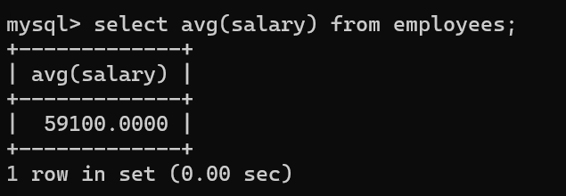
Ques11Find total salary paid per department.
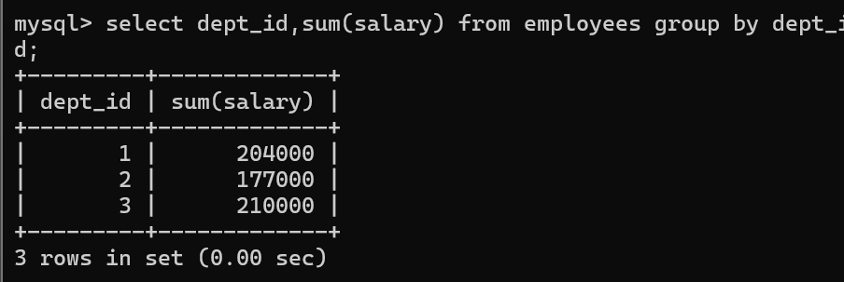
Ques12. Count employees in each department.
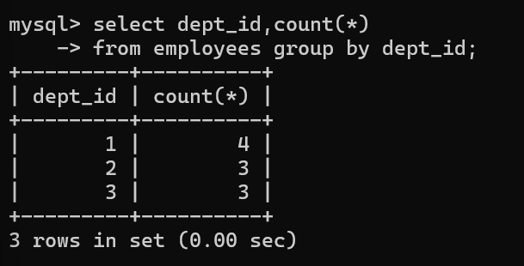
Ques13Find highest salary in each department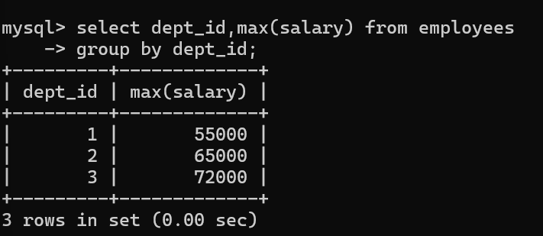
Ques14Display employees along with department names.
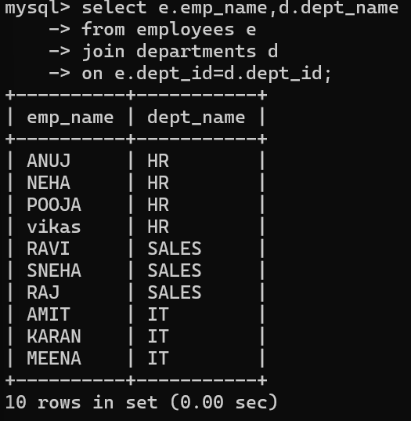
Ques15. List employees working on Sales department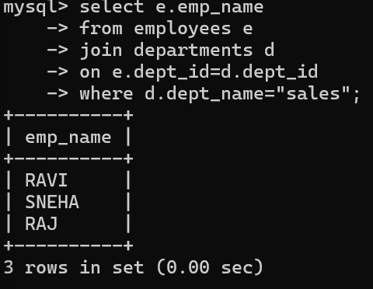
Ques16Find employees whose name starts with 'A'.
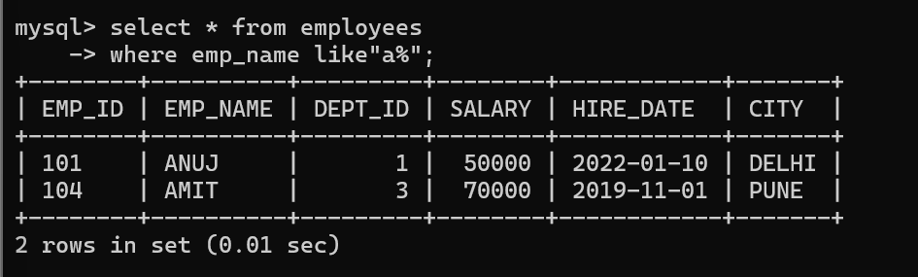
Ques17Find employees whose name starts with 'A'.
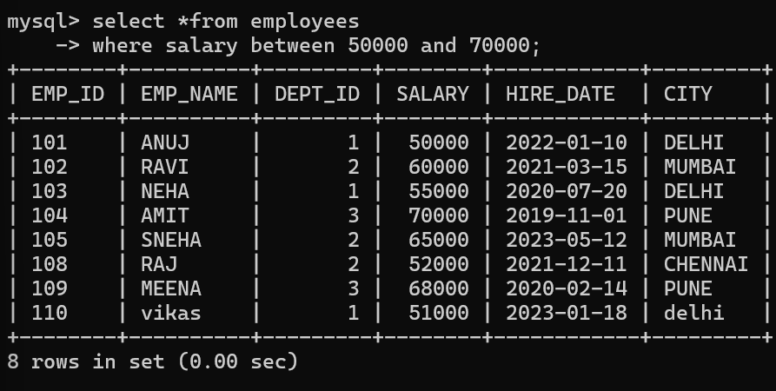
Ques18Find employees not from Mumbai. 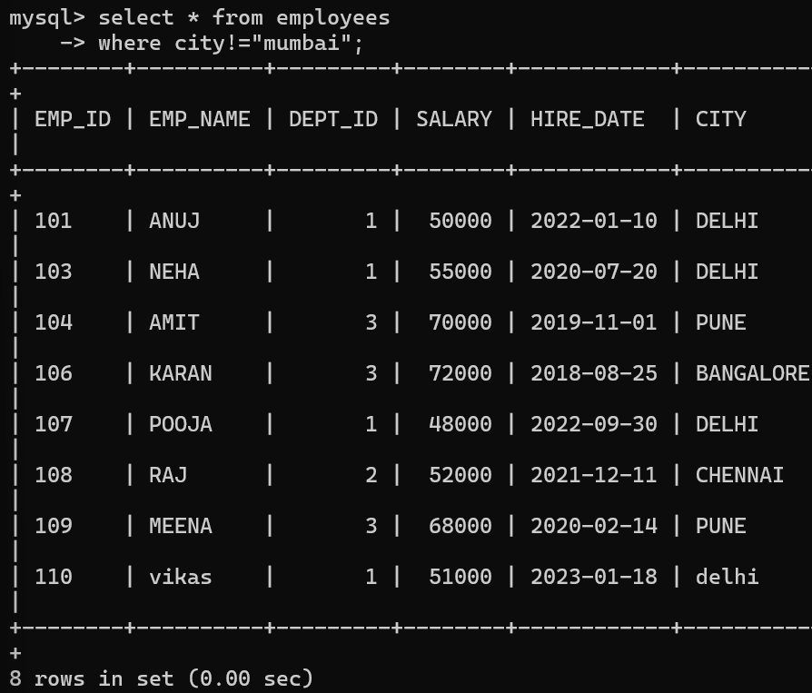
Ques19Show employees hired in 2022. 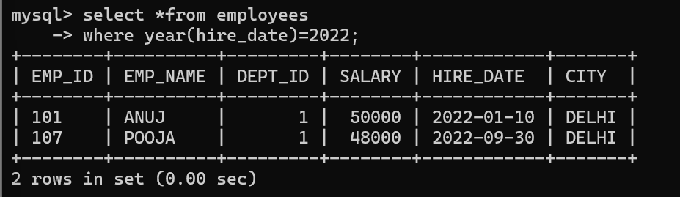
Ques20Find top 3 highest paid employees. 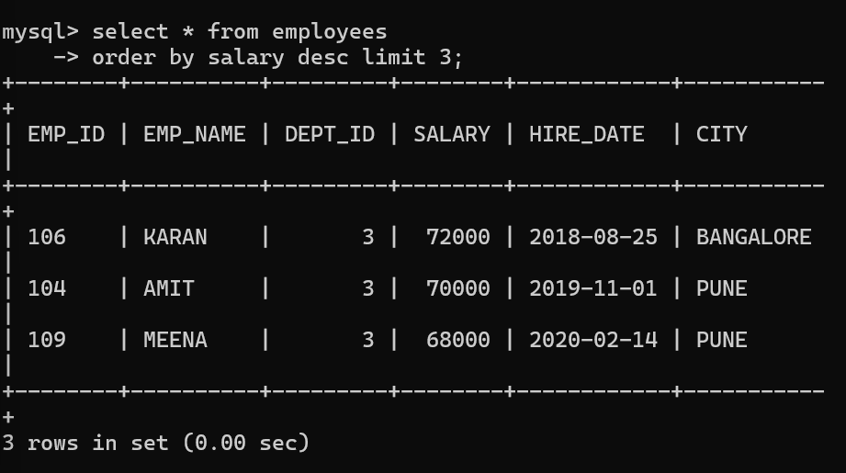
Ques21. INNER JOIN Employees and Departments.
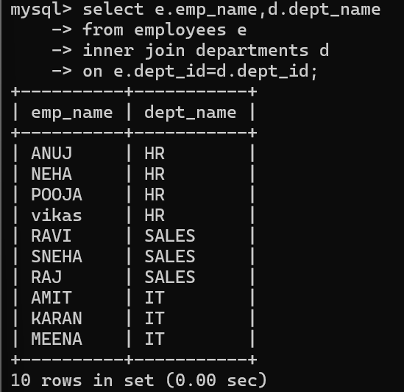
Ques22 LEFT JOIN to show all employees with department names.
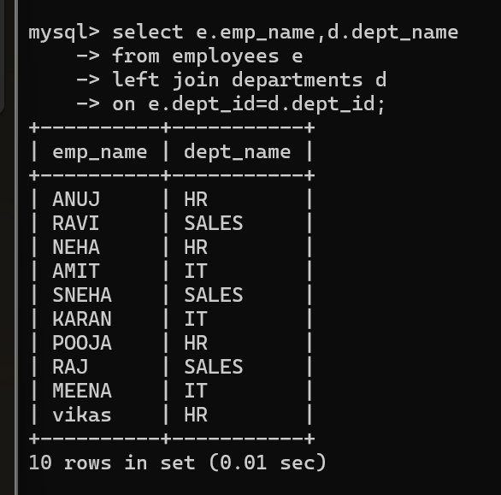
Ques23 Find employees working in IT department.
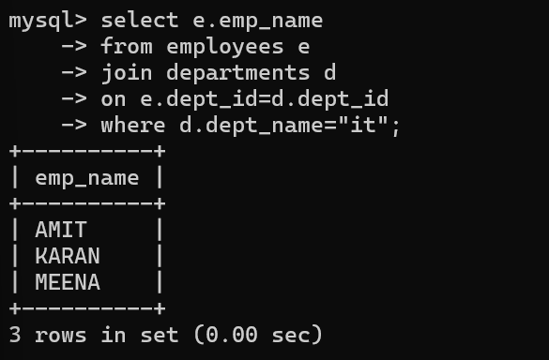
Ques24 Show project names with department names.
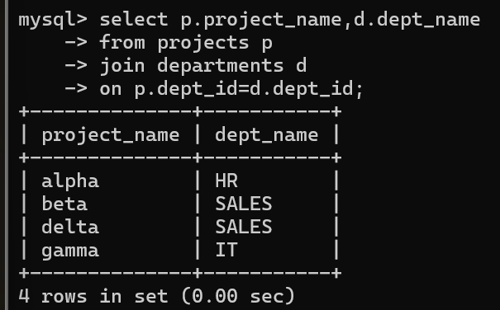
Ques25. Find employees and their project budgets (via department).
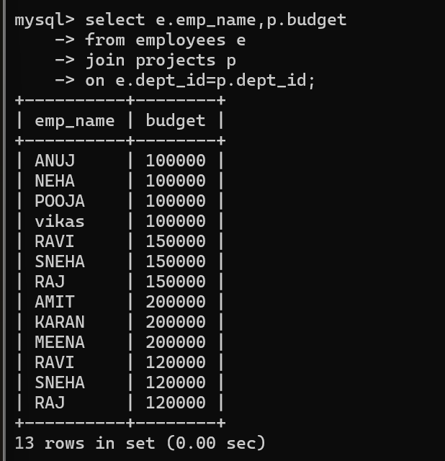
Ques26. Find second highest salary
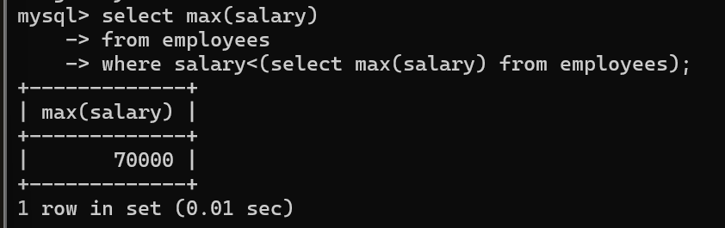
Ques27 Rank employees by salary. 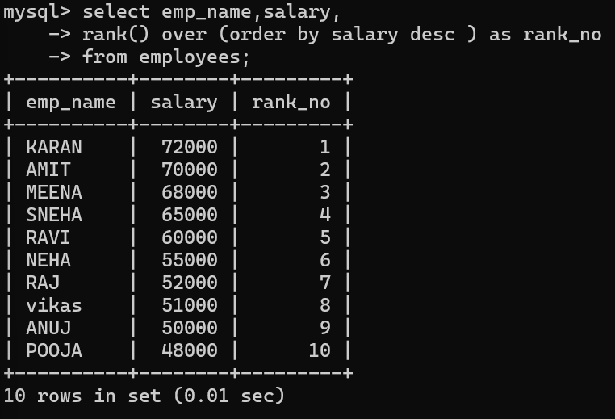
Ques28 Find employees earning above average salary. 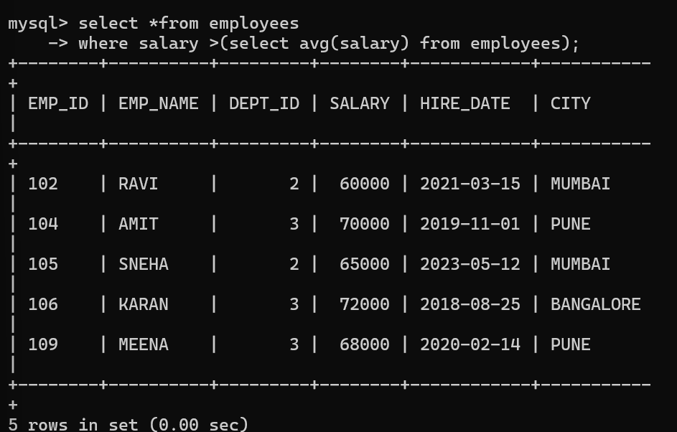
Ques29 Get department with highest total salary. 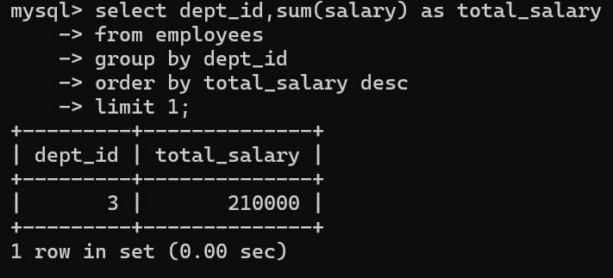

Ques30Find employees who were absent on 2024-03-01. 